**Biology: 4. The Skeleton and Movement**

***Please remember to photocopy 4 pages onto one sheet by going A3→A4 and using back to back on the photocopier***

**Syllabus**

**OB24** Identify the main parts of the human skeleton and understand that the functions are support, movement and protection

**OB25** Locate the major bones in the human body including the skull, ribs, vertebrae, collarbone, shoulder blade, humerus, radius, ulna, pelvis, femur, tibia and fibula, using a diagram or a model skeleton

**OB26** Understand the function of joints and muscles (including antagonistic pairs), tendons and ligaments, and the relationship between these and bones

**OB27** Describe the general structure and action of different types of joints: fused, ball and socket and hinged, and identify examples of each: skull, shoulder, elbow, hip, knee

**Student Notes**

**The functions of the skeleton are support, protection and movement**

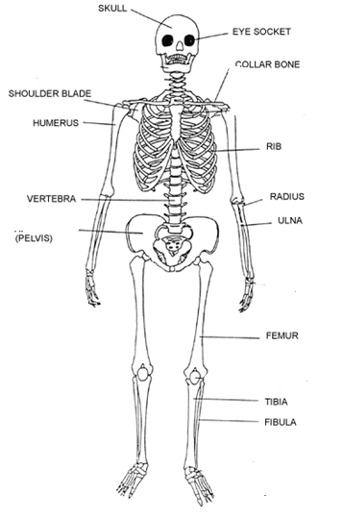

**Support**

Our skeleton supports our body and maintains its shape.

**Protection**

It also protects our soft organs; the skull protects the brain, the backbone protects the spinal cord, the ribcage protects heart and lungs etc.

**Movement**

Our skeleton also enables us to move with the help of muscles.

**Muscles and Joints**

**The function of muscles and joints is to allow movement**

**Muscles**

Bones are moved by contraction of muscles.

**Antagonistic pairs of muscles**

Usually another muscle is used to return a bone to its original position. For this reason, muscles normally occur in pairs that exert opposite forces called **antagonistic pairs**.

The world's largest jellyfish; Lion’s Mane, 8 feet in diameter and 50 meters of tentacles! 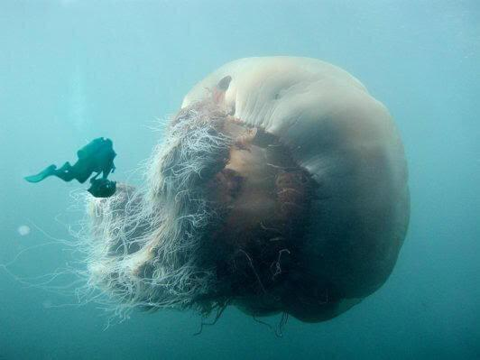

Antagonistic muscles are pairs of muscles that pull in opposite directions to control the movement of a joint e.g. biceps and triceps.

**Joints**

A joint is the place where two bones move against each other.

**Types of joints**

1. **Fused** has no movement e.g. skull
2. **Ball and Socket** allows movements in all directions, e.g. hips, shoulder
3. **Hinge** can bend in one direction only, e.g. knee, elbow

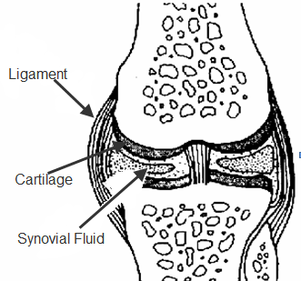

**Tendons and Ligaments**

**A tendon joins a muscle to a bone**

**(it has little elasticity and cannot be stretched)**

**A ligament joins bone to bone (it is elastic and can be stretched)**

**T**here **M**ust **B**e **L**ove **B**efore **B**abies

**T**endons: **M**uscles to **B**one, **L**igaments: **B**one to **B**one

**Synovial fluid** lubricates the joint and allows the bones to move easily (it acts as a shock absorber).

**Cartilage** is soft skeletal tissue which covers and protects the ends of bones (it also acts as a shock absorber).

*For a fun learning activity see the last page*

**Test yourself – can you identify each of the following bones?**

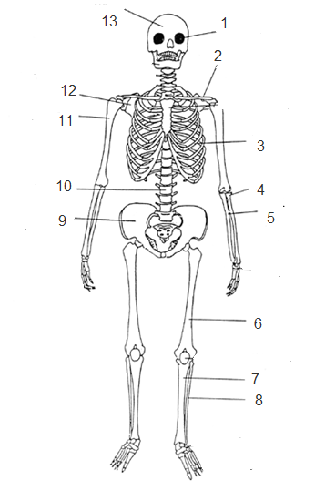

**Exam Questions**

1. [2009 OL][2008 OL][2012 OL]

Give any two functions of the human skeleton.



1. [2011 OL]
2. Name one organ protected by the ribcage.
3. Give one organ function of the skeleton.
4. [2006 OL]

Name the bone of the human skeleton labelled A in the diagram on the right.

1. [2006 OL][2007 OL][2010][2008 OL]

Name two organs that the human skull protects.

1. [2007 OL][2008 OL]

Name an organ protected by the ribs.

1. [2008 OL]

What is the name of the organ which is protected by the pelvis?

1. [2012]
2. Name the type of joint shown in the diagram.
3. Describe the movements that this type of joint can make.
4. Explain how muscles cause the movements of this joint.
5. [2007]
6. Name the type of joint found in the human skull.
7. How does this type of joint differ from other types of joints found in our bodies?



1. [2006]

The diagram shows the structure of an elbow.

1. Name bone A.
2. Identify the type of moveable joint B.



1. [2009]

The diagram shows a detailed drawing of the structure of the knee joint. The kneecap is not shown.

1. Name the bones labelled A and B.
2. What type of joint is the knee?
3. Give the functions of the parts labelled C and D in the knee.



1. [2009 OL]

Name the bones of the skeleton labelled A and B in the diagram.

1. [2009]

Explain the action of antagonistic pairs of muscles in causing the movement of limbs. You may use a labelled diagram in your answer if you wish.

1. [2007 OL]

Complete the following sentences:

1. The structure formed where two bones meet is called a ________________.
2. The tissue that causes movement of joined bones is called ______________.

**Exam Solutions**

1. Support, Shape (structure / frame), Protection, Movement, Production of blood cells
2. Heart/lungs
3. Support/movement/blood cell production/ shape
4. Femur
5. Brain/ eyes/ ear
6. Heart, lungs
7. Bladder
8. Hinge
9. backward and forward or up and down
10. the biceps (muscle) contracts bringing bones closer…

the triceps (muscle) contracts bringing bones apart…

*or*

antagonistic muscles (biceps & triceps) (pair of muscles) cause movement in opposite directions…

1. A fused of fixed joint.
2. There is no movement involved
3. Name of bone A: Humerus
4. Type of joint B: Hinge/ synovial
5. Bone A is the humerus; bone B is the femur
6. The knee is an example of a hinge joint
7. Function of C: Lubricates/ helps free movement/ reduces friction

Function of D: holds the bones together

1. Skull (cranium), B: Collar bone (clavicle)
2. Antagonistic muscles are pairs of muscles that pull in opposite directions
3. Joint
4. Muscle

**Other Test Questions**

1. List three different types of joint.
2. Write and finish the following sentence: Ligaments connect ____________ to _____________.
3. Write and finish the following sentence: Tendons connect ____________ to _____________.

Parts of the skeleton – can you identify each of these on your body?

**Fun activity**

*Write out all the parts of the skeleton on separate labels and give a set to each pair of students; the challenge is to attach them to the correct parts of the body. Who can do it the fastest? Repeat the following class and see how much your time improves. See last page for list of parts of the skeleton.*

|  |  |
| --- | --- |
| skull | pelvis |
| ribs | femur |
| vertebrae | tibia |
| collarbone | fibula |
| ball and socket jt | shoulder blade |
| radius | hinge jt |
| humerus | ulna |
| spine | patella |